# Use Test Plan Tracker.docx to keep track of correct and incorrect tests

# FriedPiper Test Plan

## Test #1 Adding FriedPiper

1. Fire Up the application. This Window should appear

1. Click the ‘Fried Pie’ Button under the ‘Treats’ section.

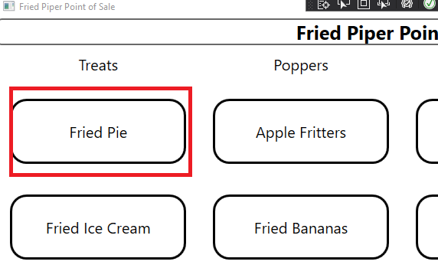

1. After Clicking the Button, your window will now look like this

1. Verify that the Menu item, contains a delete option

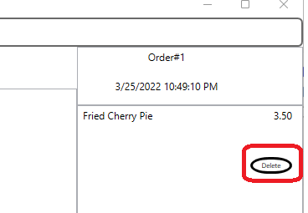

1. Verify that the name of the Menu Item is ‘Fried Cherry Pie’ corresponding to the checked ‘Cherry’ option

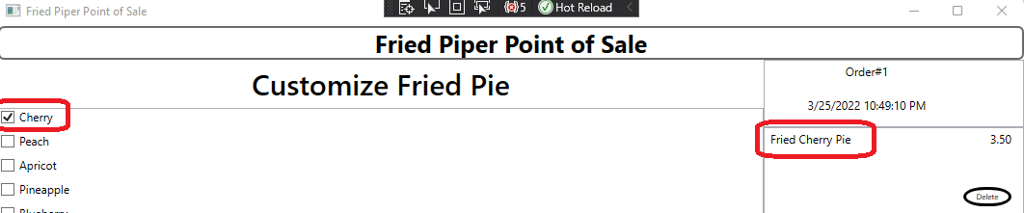

1. Verify that the Price of the Pie is 3.50 and equals the Subtotal of the order

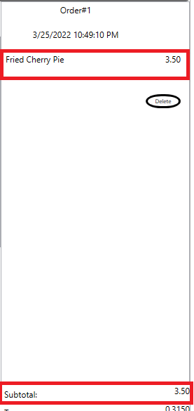

1. Verify That the Total is $3.82 and is the sum of the SubTotal and Tax. Also verify that the calories in 287.

1. In the list of checkboxes, select ‘Apricot’

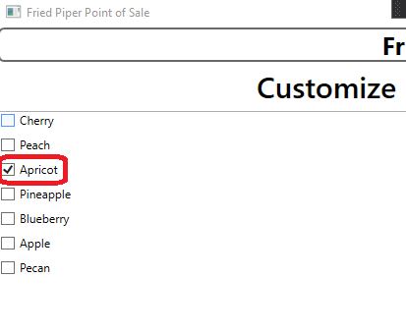

1. Verify that checking ‘Apricot’ Changes the Name of the menu item

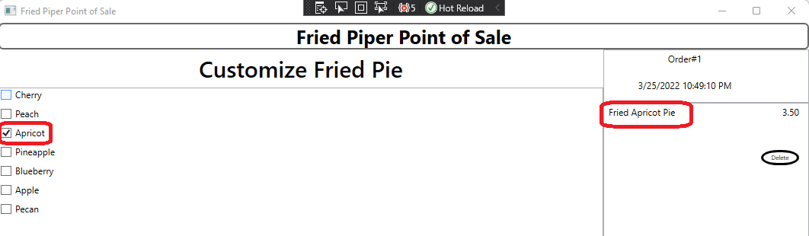

1. Verify that the calories is now 314

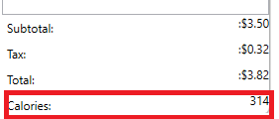

1. In the list of checkboxes, select ‘Peach

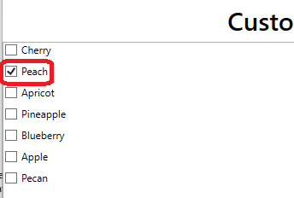

1. Verify that checking ‘Peach’ changes the Name of the menu item

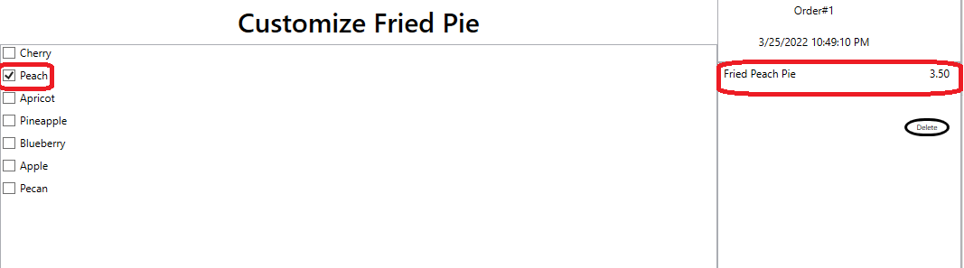

1. Verify that the calories is now 304

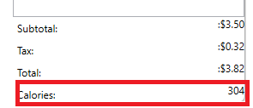

1. In the list of checkboxes, select ‘Pineapple’

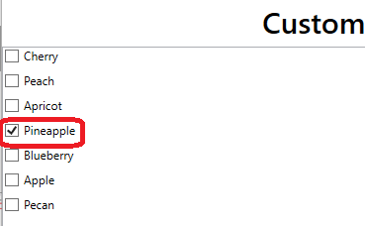

1. Verify that checking ‘Pineapple’ Changes the Name of the menu item

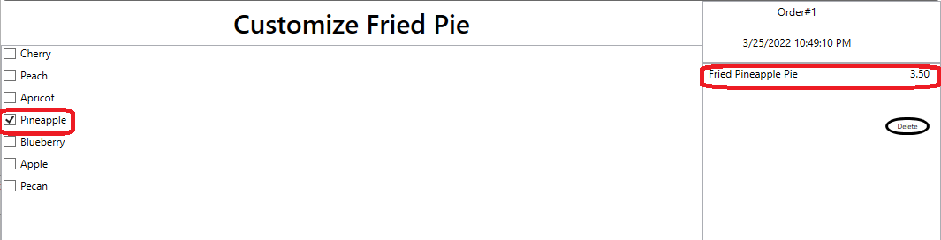

1. Verify that the Calories is now 302

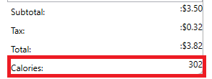

1. In the list of checkboxes, select ‘Blueberry’

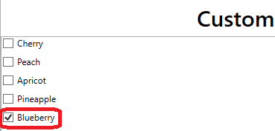

1. Verify that checking ‘Blueberry’ Changes the Name of the menu item

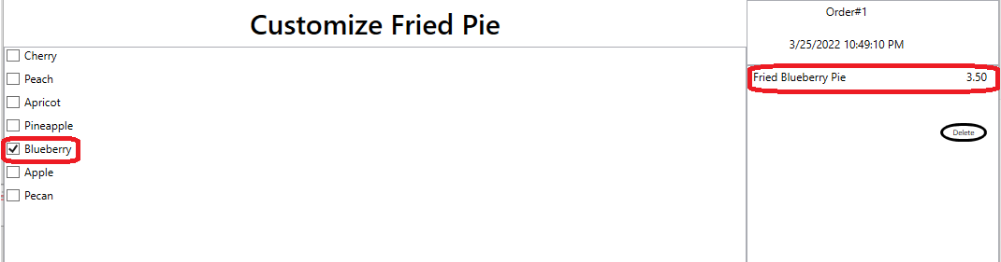

1. Verify that the calories in now 314

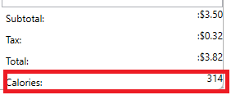

1. In the list of checkboxes, select ‘Apple’

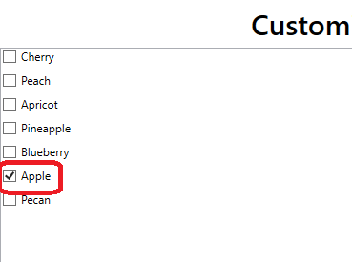

1. Verify that checking ‘Apple’ Changes the Name of the menu item

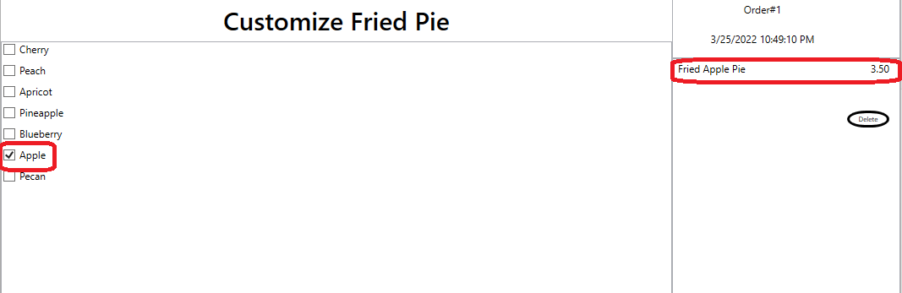

1. Verify that the Calories in now 289

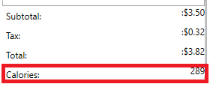

1. In the list of checkboxes, select ‘Pecan’

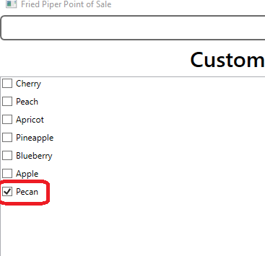

1. Verify that checking ‘Pecan’ Changes the Name of the menu item

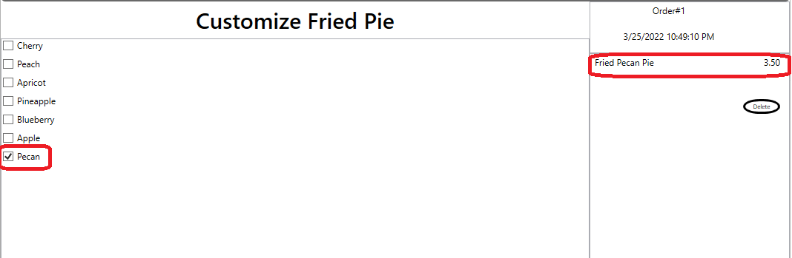

1. Verify that the Calories is now 314



1. Click the ‘Select More Items’ Button

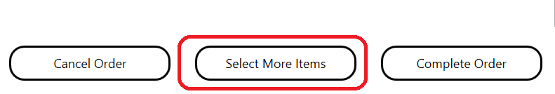

1. The Window Should look like this

1. Click the ‘Complete Order’ Button

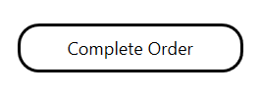

1. Your Window Should Look Like this. Verify that the Order number changed.

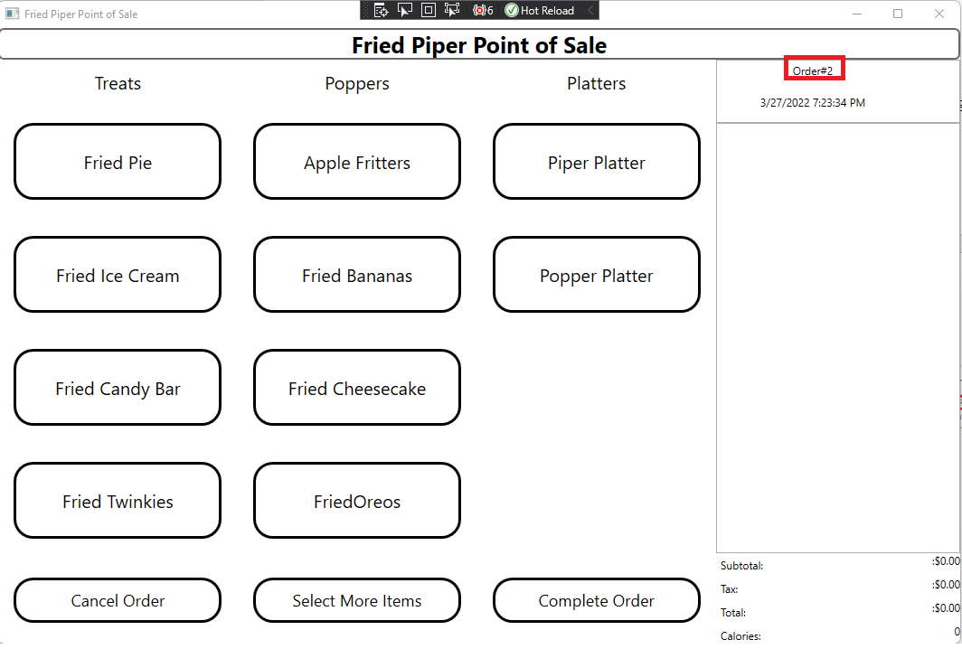

## Test #2 Adding FriedIceCream

1. Click the ‘Fried Ice Cream’ Button under the ‘Treats’ section.

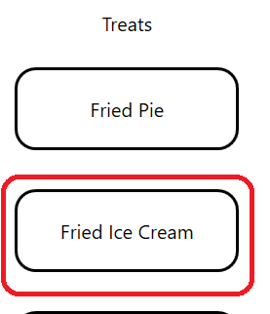

1. After clicking the ‘Fried Ice Cream’ button your window should now look like this.

1. Verify that the Menu item, contains a delete option

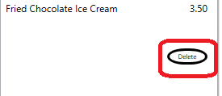

1. Verify that the name of the Menu Item is ‘Fried Chocolate Ice Cream’ corresponding to the checked ‘Chocolate option

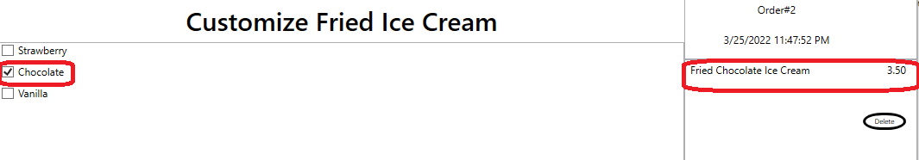

1. Verify that the Price of the Ice Cream equals the Subtotal of the order

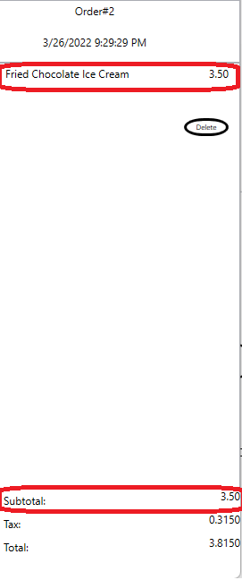

1. Verify That the Total is the SubTotal plus the Tax. Also verify that the Calories is 353.

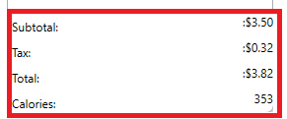

1. In the list of checkboxes, select ‘Vanilla’

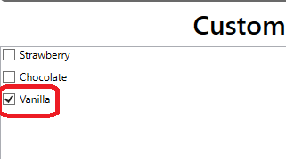

1. Verify that the name of the Menu Item is ‘Fried Vanilla Ice Cream’ corresponding to the checked ‘Vanilla’ option

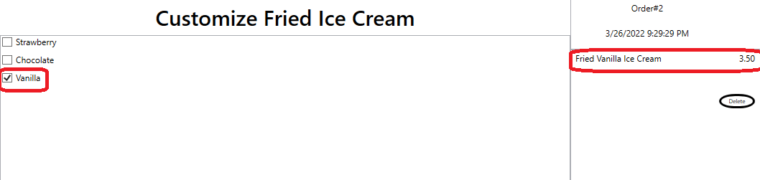

1. Verify that the Calories is now 355

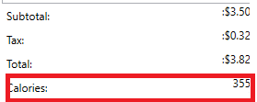

1. In the list of checkboxes, select ‘Strawberry’

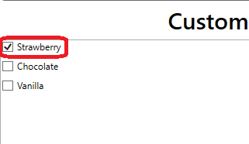

1. Verify that the name of the Menu Item is ‘Fried Strawberry Ice Cream’ corresponding to the checked ‘Strawberry’ option

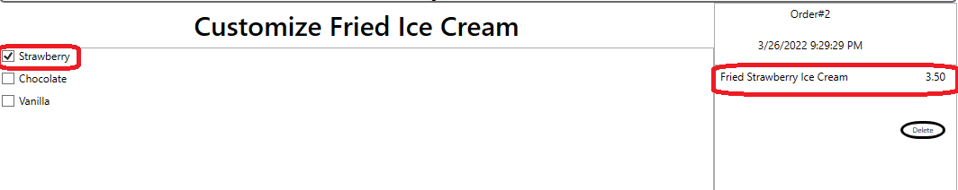

1. Verify that the Calories is now 321

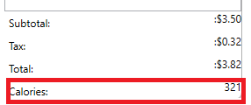

1. Click the ‘Select More Items’ button

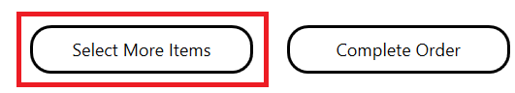

1. Verify that the Screen now Looks like this

1. Move on to the Test #3 ‘Adding FriedCandyBar’

## Test #3 Adding FriedCandyBar

1. Click the ‘Fried Candy Bar’ Button under the ‘Treats’ section.

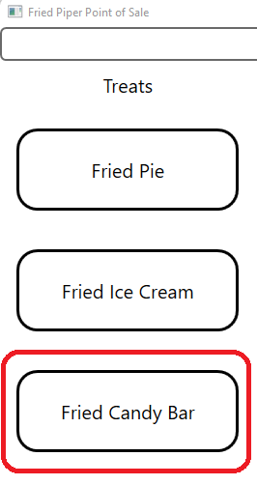

1. After clicking the ‘Fried Candy Bar’ button your window should now look like this.

1. Verify that the Menu item, contains a delete option

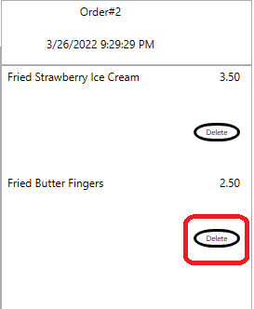

1. Verify that the name of the Menu Item is ‘Fried Butter Fingers’ corresponding to the checked ‘ButterFingers’ option

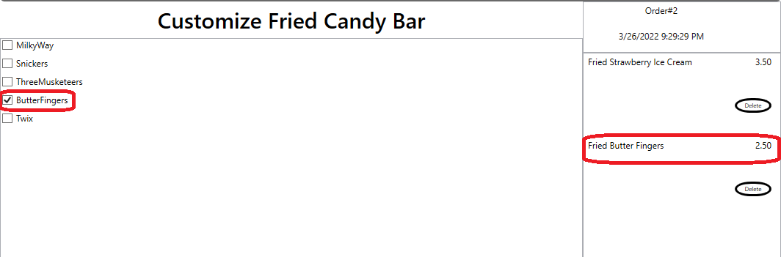

1. Verify that the Price of the Candy Bar plus the Ice Cream equals the Subtotal of the order

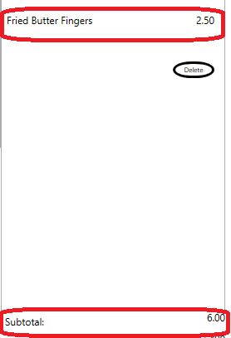

1. Verify That the Total 6.54 is sum of the SubTotal and the Tax. Also verify that the Calories is 706, the sum of the Fried Strawberry Ice Cream and Fried Butter Fingers calories.

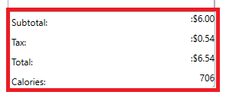

1. In the list of checkboxes, select ‘Milkyway’

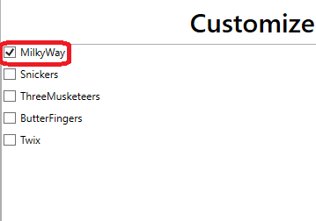

1. Verify that the name of the Menu Item is ‘Fried MilkyWay’ corresponding to the checked ‘Milkyway’ option

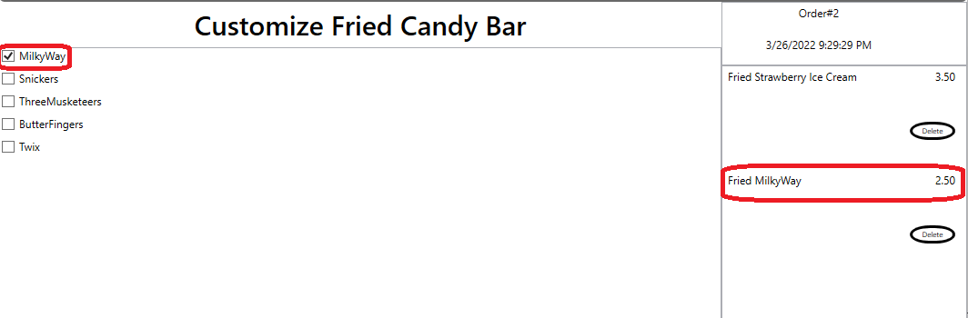

1. Verify that the calories is now 534

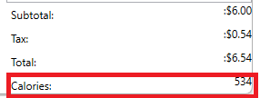

1. In the list of checkboxes, select ‘Snickers’

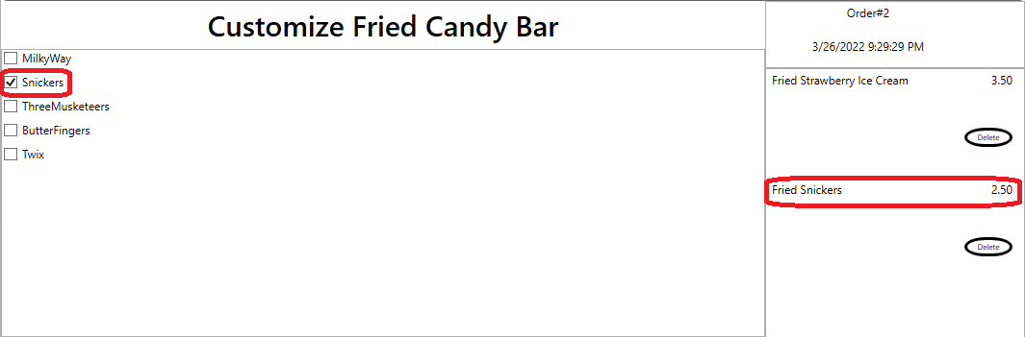

1. Verify that the name of the Menu Item is ‘Fried Snickers’ corresponding to the checked ‘Snickers’ option

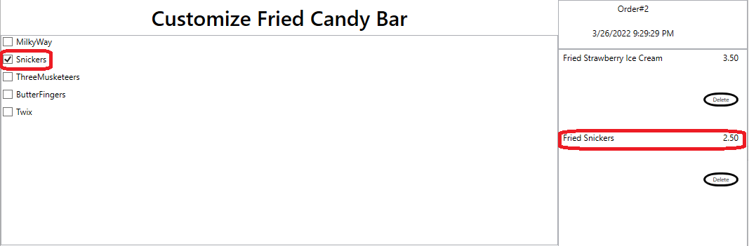

1. Verify that the calories is now 646

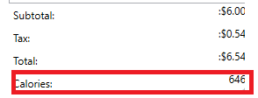

1. In the list of checkboxes, select ‘ThreeMusketeeers’

1. Verify that the name of the Menu Item is ‘Fried Three Musketeers’ corresponding to the checked ‘ThreeMusketeers’ option

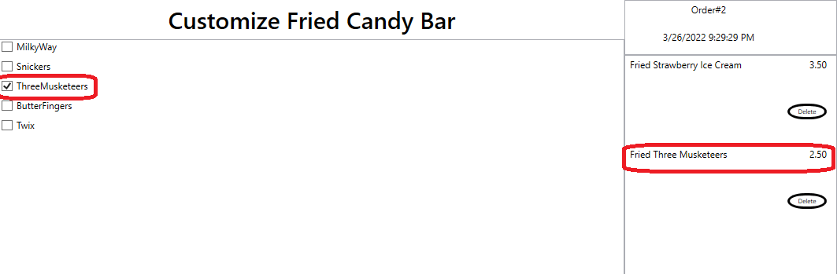

1. Verify that the Calories is now 671

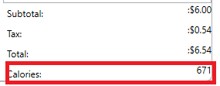

1. In the list of checkboxes, select ‘Twix’

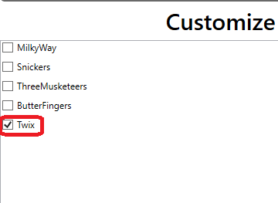

1. Verify that the name of the Menu Item is ‘Fried Twix’ corresponding to the checked ‘Twix’ option

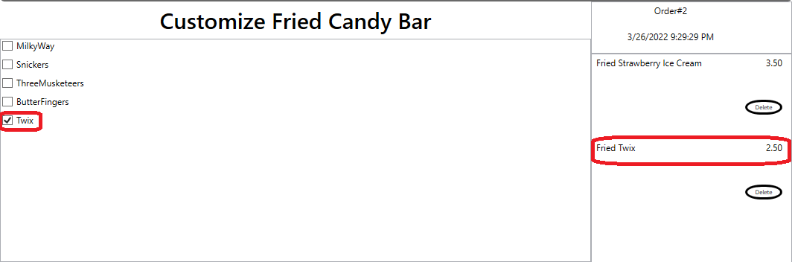

1. Verify that the Calories is now 717

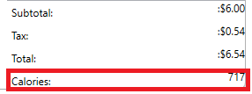

1. Click the ‘Select More Items’ button



1. Verify that the Screen now Looks like this

1. Move on to Test #4 – ‘Adding FriedTwinkie”

## Test #4 Adding FriedTwinkie

1. Click the ‘Fried Twinkies’ button under the ‘Treats’ Section

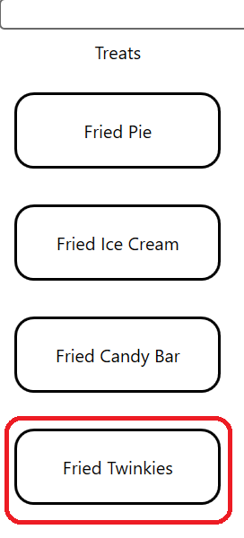

1. After Clicking the ‘Fried Twinkies’ button your window should now look like this

1. Very that the order list contains a Menu Item named ‘Fried Twinkies’

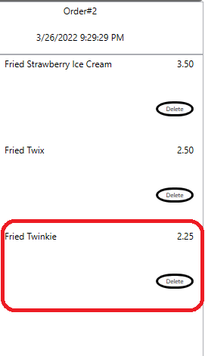

1. Verify that the Fried Twinkie Menu Item contains a delete button

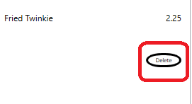

1. Verify that adding the Fried Twinkie changes the SubTotal to the correct value. The SubTotal should equal the sum of the Fried Twinkie, Fried Twix, and Fried Strawberry Ice Cream menu item prices.

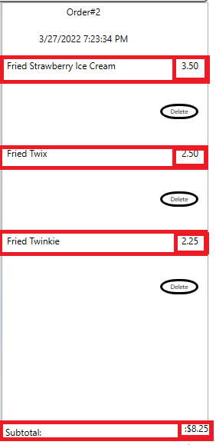

1. Verify that the Total equals the SubTotal plus the Tax. Also verify that the Calories is 1137, the sum of the Fried Strawberry Ice Cream, Fried Twix, Fried Twinkie calories

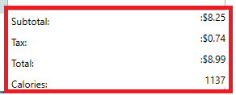

1. Click the ‘Select More Items’ button



1. Verify that the Screen now Looks like this

1. Exit the Application.

## Test #5 Adding Apple Fritters

1. Fire Up the application. This Window should appear

1. Click the ‘Apple Fritters’ button under the ‘Poppers’ section.

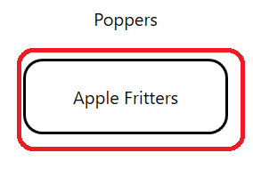

1. Your window should now look like this.

1. Verify that the name of the Menu Item is ‘Small Apple Fritters’ corresponding to the checked ‘Small’ option. Also verify that the Small Apple Fritter is Glazed

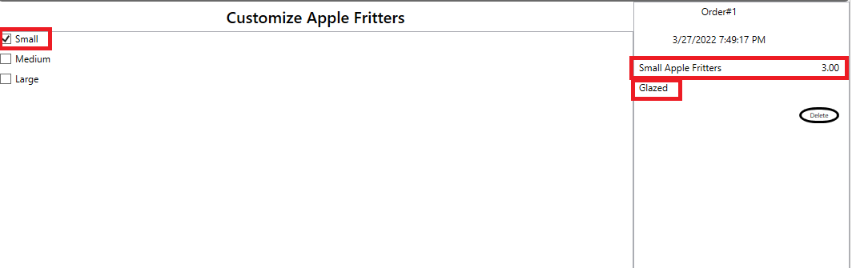

1. Verify that “Small Apple Fritters” menu item has a delete button

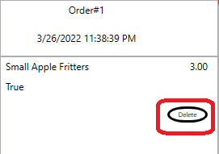

1. Verify that the price of the ‘Small Apple Fritters’ Menu Item is 3.00 and matches the SubTotal of the order.

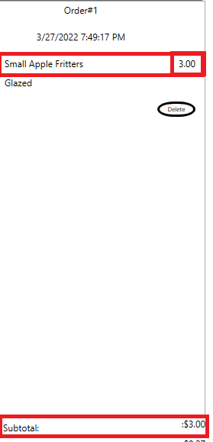

1. Verify that the Total is 3.27 and is the sum of the Subtotal and Tax. Also verify that the Calories in now 327.

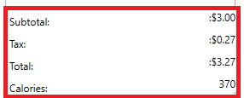

1. Uncheck the Glazed option under the ‘Glazing’ section

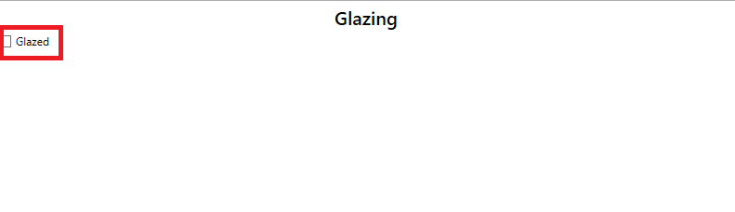

1. Verify that the Calories is now 240.

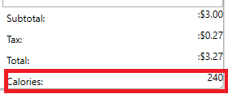

1. Verify that the Small Apple Fritter is not glazed

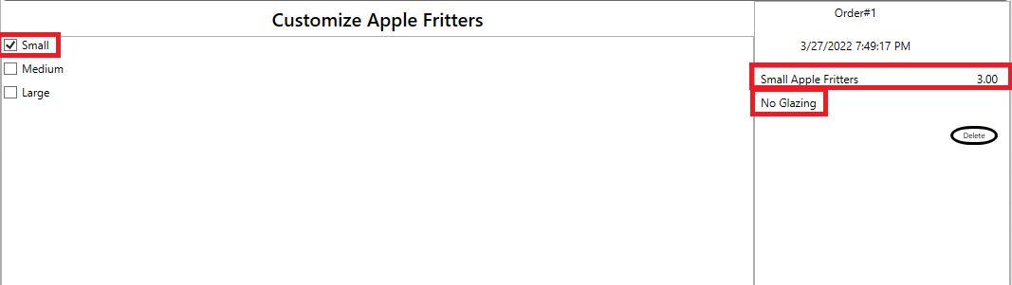

1. Check the Medium option under the ‘Customize Apple Fritters’ section

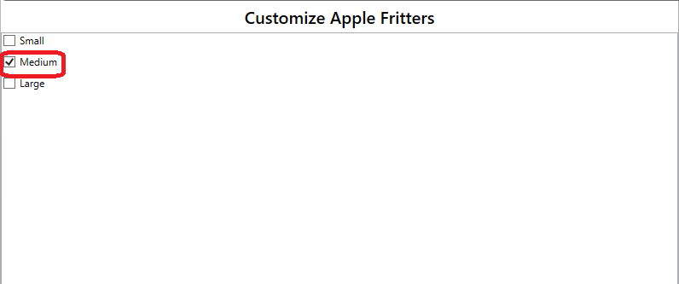

1. Verify that the name of the Menu Item is ‘Medium Apple Fritters’ corresponding to the checked ‘Medium’ option. Also verify that the Medium Apple Fritter has no glazing

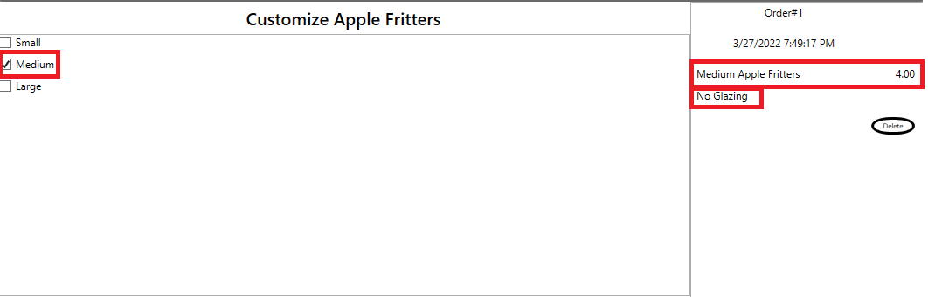

1. Verify that the price of the ‘Medium Apple Fritters’ Menu Item is 4.00 and matches the SubTotal of the order. Also verify that the calories in now 360

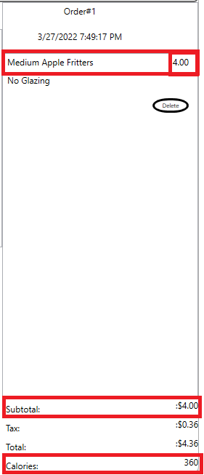

1. Verify that the Total is 4.36 and is the sum of the Subtotal and Tax

1. Check the Glazed option under the ‘Glazing’ section

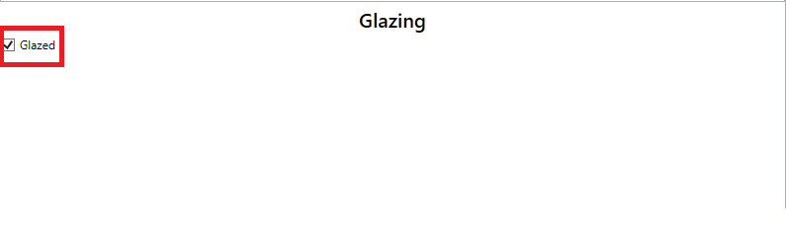

1. Verify that the Calories is now 490.

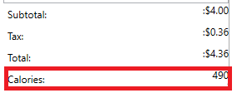

1. Check the Large option under the ‘Customize Apple Fritters’ section

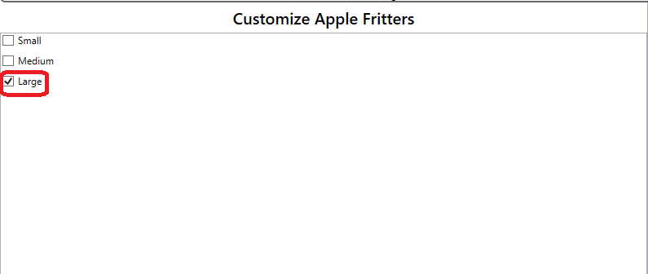

1. Verify that the name of the Menu Item is ‘Large Apple Fritters’ corresponding to the checked ‘Large’ option. Also verify that the Large Apple Fritter is Glazed

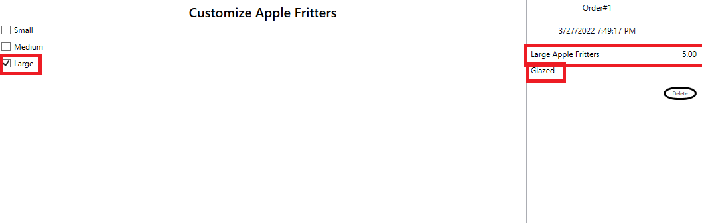

1. Verify that the price of the ‘Large Apple Fritters’ Menu Item is 5.00 and matches the SubTotal of the order.

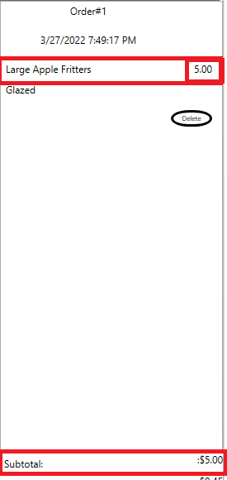

1. Verify that the Total is 5.45 and is the sum of the Subtotal and Tax. Also verify that the calories is 610.

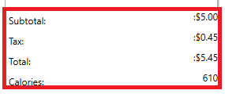

1. Under the Glazing Section of the Window, uncheck Glazed.



1. Verify that the Large Apple Fritter is has no glazing and the new calories in 480.

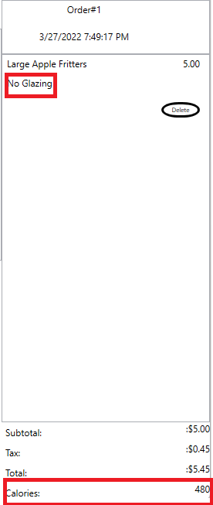

1. Click the ‘Select More Items’ button

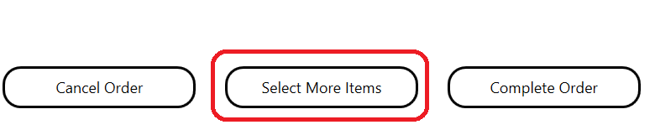

1. Your window should now look like this.

1. Exit The Application

## Test #6 Adding Fried Bananas

1. Fire Up the application. This Window should appear

1. Click the ‘Fried Bananas’ button under the ‘Poppers’ section.

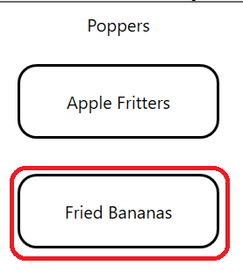

1. Your window should now look like this.

1. Verify that the name of the Menu Item is ‘Small Fried Bananas’ corresponding to the checked ‘Small’ option. Also verify that the Small Fried Bananas is Glazed

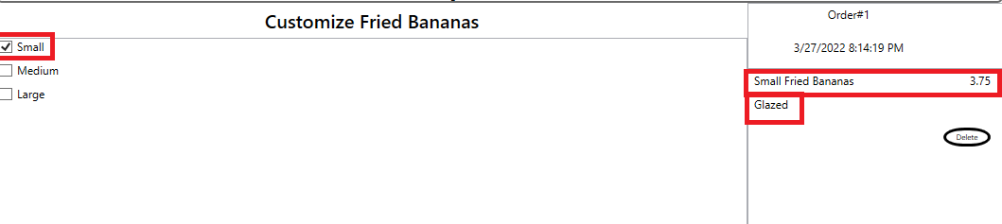

1. Verify that “Small Fried Bananas” meu item has a delete button

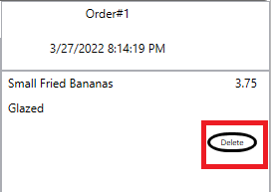

1. Verify that the price of the ‘Small Apple Fritters’ Menu Item is 3.75 and matches the SubTotal of the order.

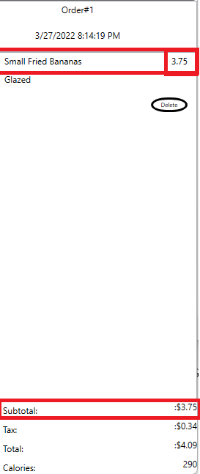

1. Verify that the Total is 4.09 and is the sum of the Subtotal and Tax. Also verify that the Calories in now 290.

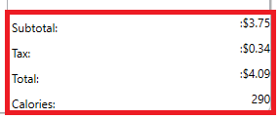

1. Uncheck the Glazed option under the ‘Glazing’ section



1. Verify that the Calories is now 160

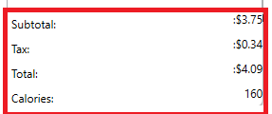

1. Verify that the Small Fried Bananas has no glazing

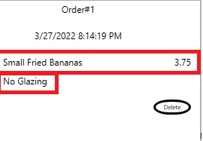

1. Check the Medium option under the ‘Customize Fried Bananas’ section

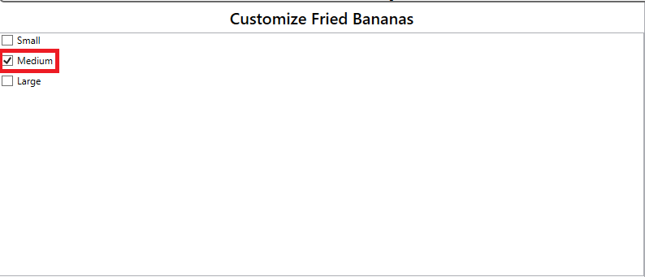

1. Verify that the name of the Menu Item is ‘Medium Fried Bananas’ corresponding to the checked ‘Medium’ option. Also verify that the Medium Apple Fritter has no glazing.

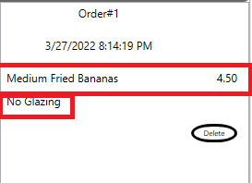

1. Verify that the price of the ‘Medium Fried Bananas’ Menu Item is 4.50 and matches the SubTotal of the order. Also verify that the Calories is now 240

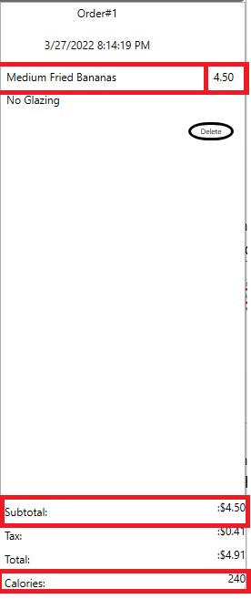

1. Verify that the Total is 4.91 and is the sum of the Subtotal and Tax. Also verify that the calories in 240.

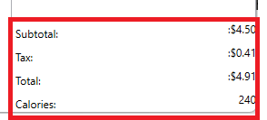

1. Check the Glazed option under the ‘Glazing’ section



1. Verify that the Calories is now 370

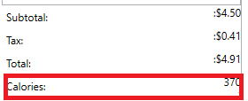

1. Check the Large option under the ‘Customize Fried Bananas’ section



1. Verify that the name of the Menu Item is ‘Large Fried Bananas’ corresponding to the checked ‘Large’ option. Also verify that the Large Fried Bananas is Glazed

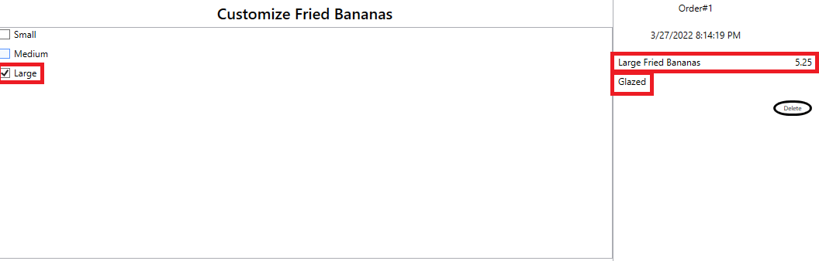

1. Verify that the price of the ‘Large Fried Bananas’ Menu Item is 5.25 and matches the SubTotal of the order.

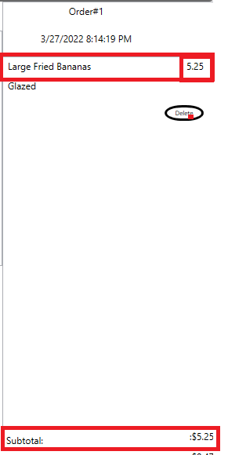

1. Verify that the Total is 5.72 and is the sum of the Subtotal and Tax

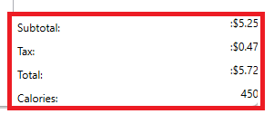

1. Under the Glazing Section of the Window, uncheck Glazed.



1. Verify that the Large Fried Banas has no glazing and the calories is 320.

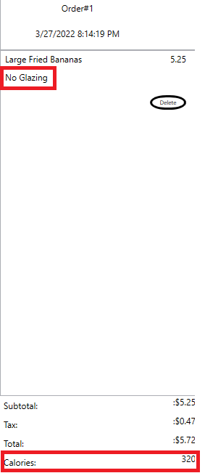

1. Click the ‘Select More Items’ button



1. Your window should now look like this.

1. Move on to Test #7 to Adding Fried Cheesecake

## Test #7 Adding Fried Cheesecake

1. Click the ‘Fried Cheesecake’ button under the ‘Poppers’ section.

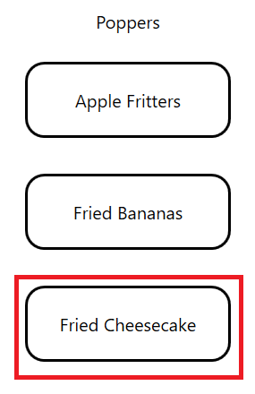

1. Your window should now look like this.

1. Verify that the name of the Menu Item is ‘Small Fried Cheesecake’ corresponding to the checked ‘Small’ option. Also verify that the Small Fried Cheesecake is Glazed

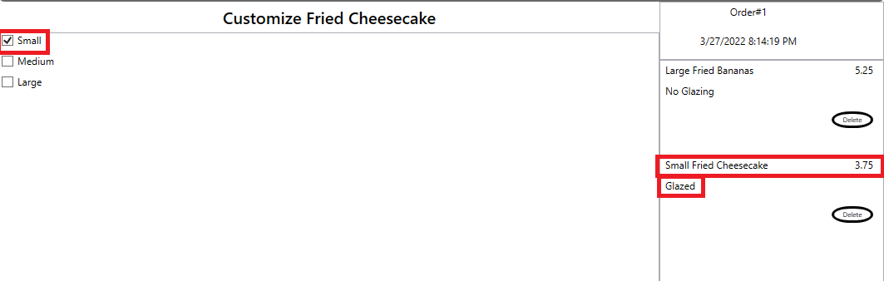

1. Verify that “Small Fried Cheesecake” menu item has a delete button

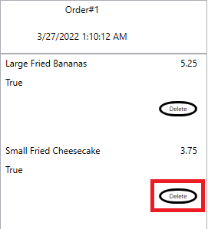

1. Verify that the price of the ‘Small Fried Cheesecake’ Menu Item is 3.75 and the SubTotal is 9.00, the sum of the Large Fried Bananas and the Small Fried Cheesecake.

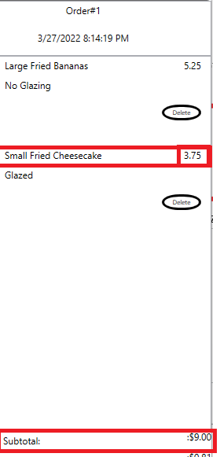

1. Verify that the Total is 9.81 and is the sum of the Subtotal and Tax. Also verify that the Calories in 760. The sum of the unglazed Large Fried Bananas and the glazed Small Fried Cheesecake.

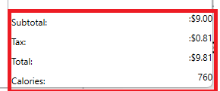

1. Uncheck the Glazed option under the ‘Glazing’ section



1. Verify that the Calories is now 240.

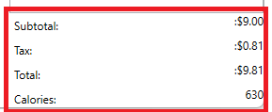

1. Verify that the Small Fried Cheesecake has no glazing

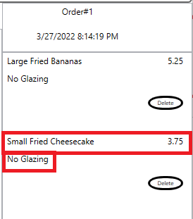

1. Check the Medium option under the ‘Customize Fried Cheesecake’ section

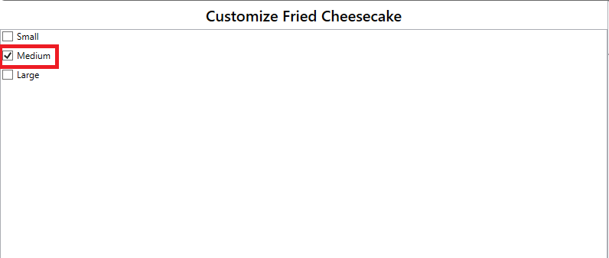

1. Verify that the name of the Menu Item is ‘Medium Fried Cheesecake’ corresponding to the checked ‘Medium’ option. Also verify that the Medium Fried Cheesecake has no glazing

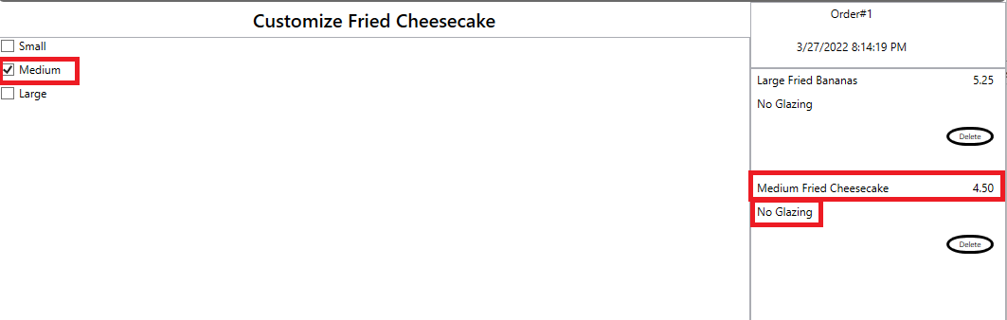

1. Verify that the price of the ‘Medium Fried Cheesecake’ Menu Item is 4.50 and the SubTotal is 9.75, the sum of the Large Fried Bananas and the Medium Fried Cheesecake.

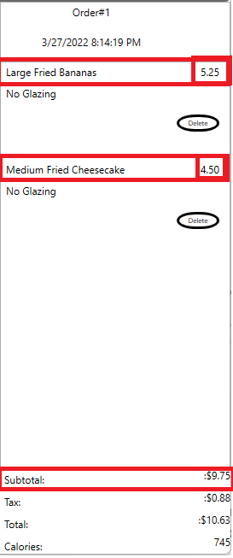

1. Verify that the Total is 10.63 and is the sum of the Subtotal and Tax. Also verify that the Calories is now 745.

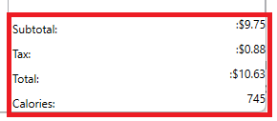

1. Check the Glazed option under the ‘Glazing’ section



1. Verify that the Calories is now 875

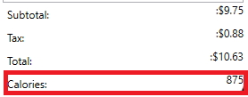

1. Check the Large option under the ‘Customize Fried Cheesecake’ section

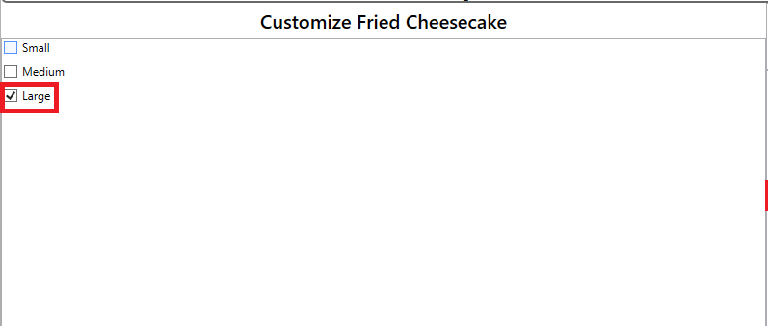

1. Verify that the name of the Menu Item is ‘Large Fried Cheesecake’ corresponding to the checked ‘Large’ option. Also verify that the Large Fried Cheesecake is Glazed

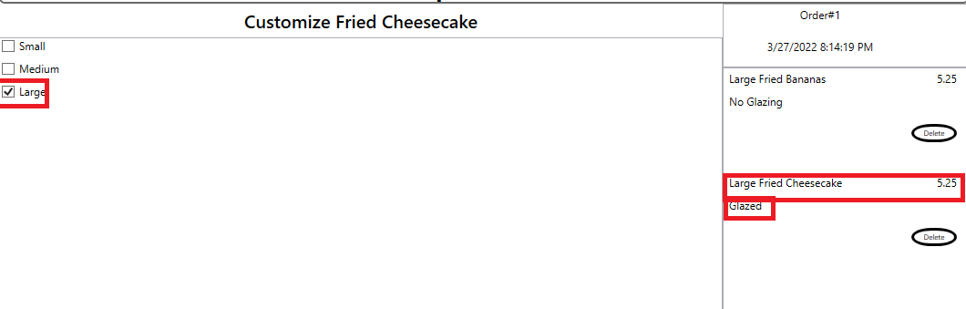

1. Verify that the price of the ‘Large Fried Cheesecake’ Menu Item is 5.25 and the SubTotal is 10.50, the sum of the Large Fried Bananas and the Large Fried Cheesecake.

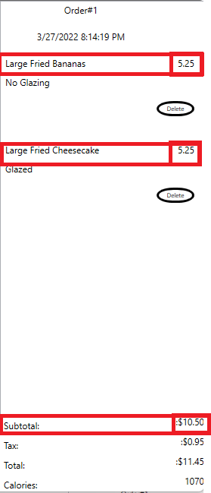

1. Verify that the Total is 11.45 and is the sum of the Subtotal and Tax. Also verify that the calories is 1070

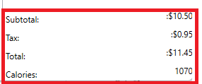

1. Under the Glazing Section of the Window, uncheck Glazed.



1. Verify that the Large Fried Cheesecake has no glazing and the new calories in 480

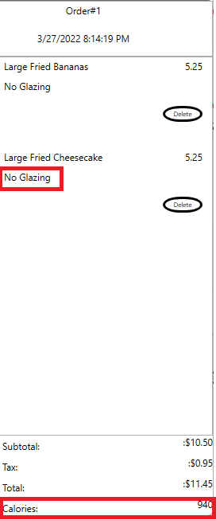

1. Click the ‘Select More Items’ button



1. Your window should now look like this.

1. Move on to Test #8 Adding “Fried Oreos”

## Test #8 Adding Fried Oreos

1. Click the ‘FriedOreos’ button under the ‘Poppers’ section.

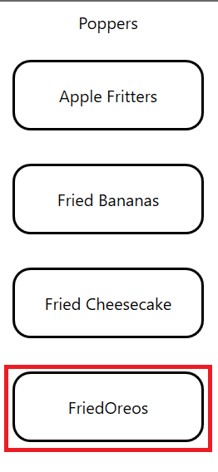

1. Your window should now look like this.

1. Verify that the name of the Menu Item is ‘Small Fried Oreos’ corresponding to the checked ‘Small’ option. Also verify that the Small Fried Oreos is Glazed.

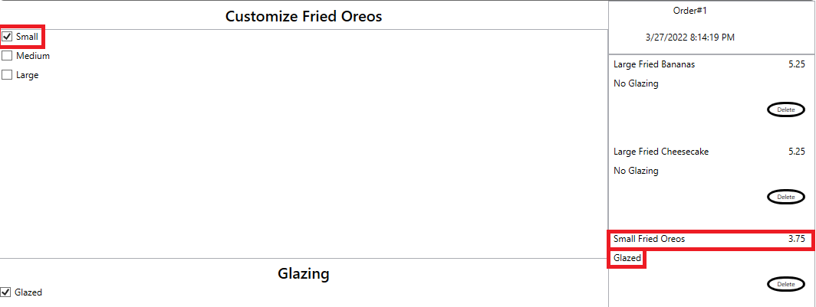

1. Verify that “Small Fried Oreos” menu item has a delete button

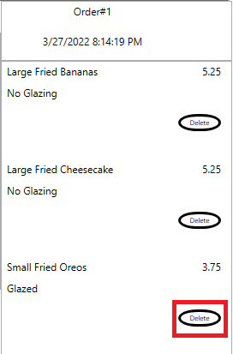

1. Verify that the price of the ‘Small Fried Oreos’ Menu Item is 3.75 and the SubTotal of the order is 14.25 the sum of Large Fried Bananas, Large Fried Cheesecake, and Small Fried Oreos.

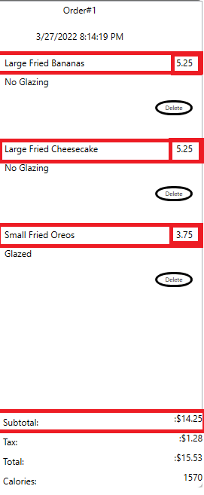

1. Verify that the Total is 9.81 and is the sum of the Subtotal and Tax. Also verify that the Calories in 760. The sum of the unglazed Large Fried Bananas and the unglazed Large Fried Cheesecake and the glazed Small Fried Oreos

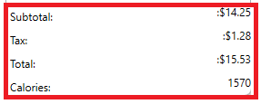

1. Uncheck the Glazed option under the ‘Glazing’ section



1. Verify that the calories is now 1440

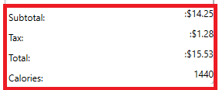

1. Verify that the Small Fried Oreos has no Glazing

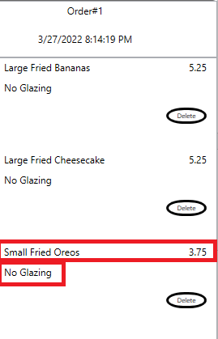

1. Check the Medium option under the ‘Customize Fried Oreos’ section

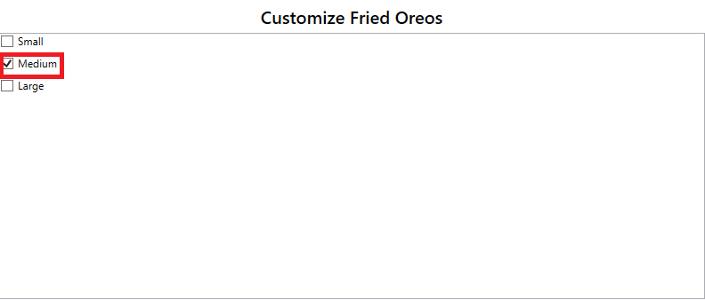

1. Verify that the name of the Menu Item is ‘Medium Fried Oreos’ corresponding to the checked ‘Medium’ option. Also verify that the Medium Fried Oreos has no glazing

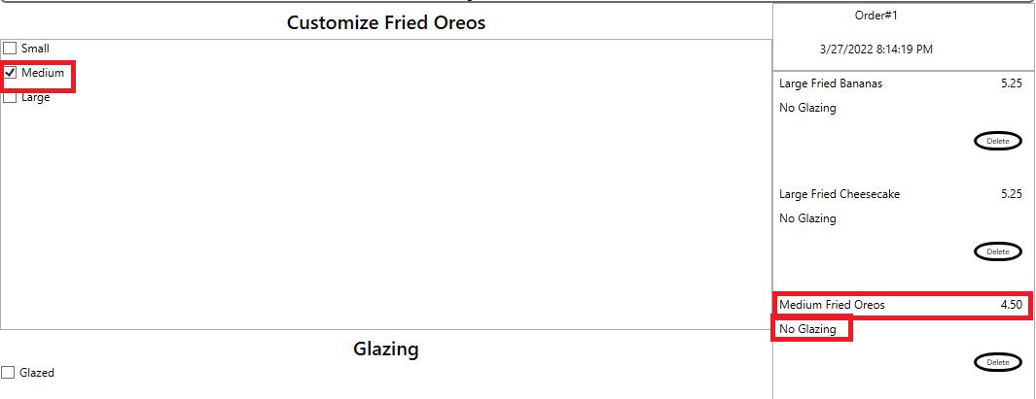

1. Verify that the price of the ‘Medium Fried Oreos’ Menu Item is 4.50 and the SubTotal of the order is 15.00, the sum of the Large Fried Bananas, Large Fried Cheesecake, and Medium Fried Oreos.

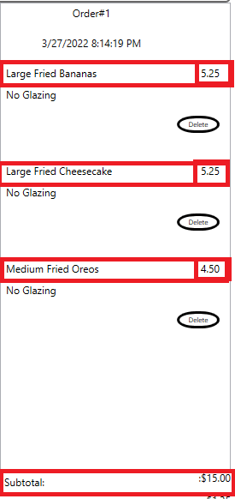

1. Verify that the Total is 16.35 and is the sum of the Subtotal and Tax. Also verify that the calories in now 1690

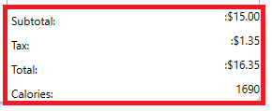

1. Check the Glazed option under the ‘Glazing’ section



1. Verify that the Calories is now 1820

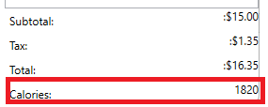

1. Check the Large option under the ‘Customize Fried Oreos’ section

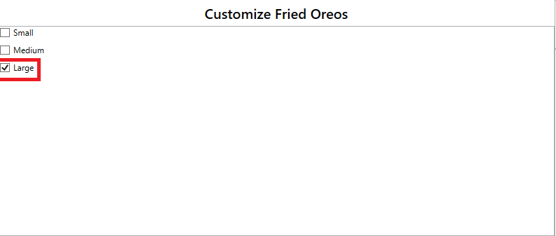

1. Verify that the name of the Menu Item is ‘Large Fried Oreos’ corresponding to the checked ‘Large’ option. Also verify that the Large Fried Oreos is Glazed

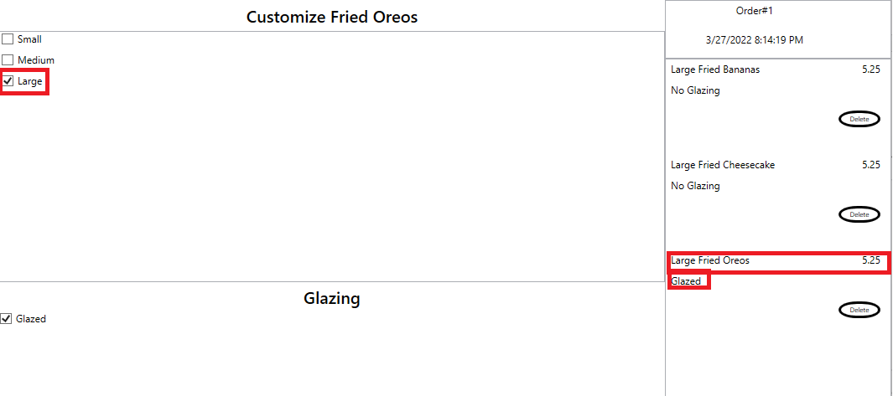

1. Verify that the price of the ‘Large Fried Oreos’ Menu Item is 5.25 and the SubTotal of the order is 15.75, the sum of Large Fried Bananas, Large Fried Cheesecake, and Large Fried Oreos.

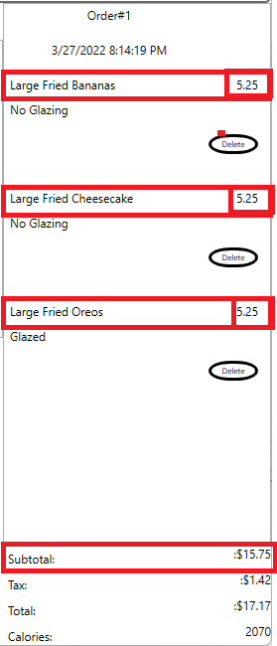

1. Verify that the Total is 17.17 and is the sum of the Subtotal and Tax. Also verify that the calories

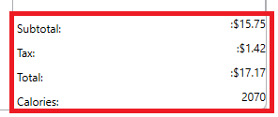

1. Click the ‘Select More Items’ button



1. Your window should now look like this.

1. Move on to Test #9 Adding Popper Platter

## Test #9 Adding Popper Platter

1. Click the ‘Popper Platter’ button under the ‘Platters’ section.

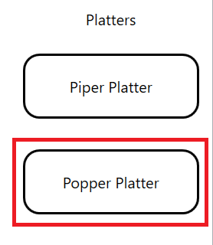

1. Your window should now look like this.

1. Verify that the name of the Menu Item is ‘Small Popper Platter’ corresponding to the checked ‘Small’ option. Also verify that the Small Popper Platter is Glazed.

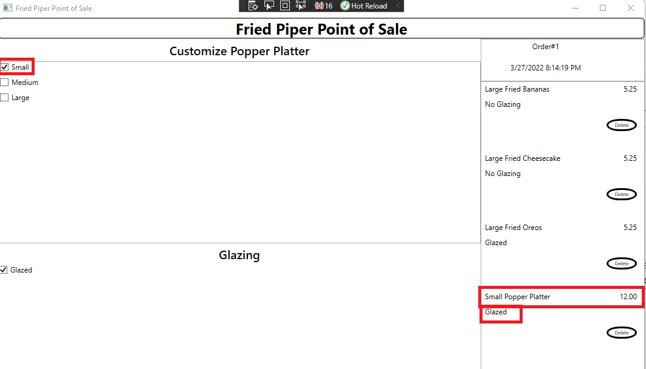

1. Verify that “Small Popper Platter” menu item has a delete button

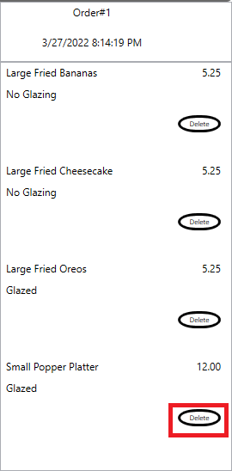

1. Verify that the price of the ‘Small Popper Platter’ Menu Item is 12.00 and the SubTotal of the order is the sum of Large Fried Bananas, Large Fried Cheesecake, and Large Fried Oreos, and Small Popper Platter.

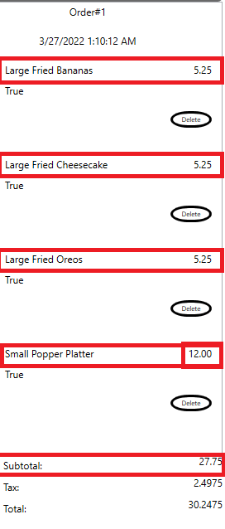

1. Verify that the Total is 30.25 and is the sum of the Subtotal and Tax. Also verify that the Calories in 3800. The sum of the unglazed Large Fried Bananas and the unglazed Large Fried Cheesecake, the glazed Large Fried Oreos, and the glazed small Popper Platter.

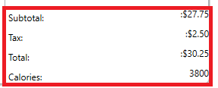

1. Uncheck the Glazed option under the ‘Glazing’ section



1. Verify that the Calories is now 3280

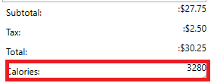

1. Verify that the Small Popper Platter has no glazing

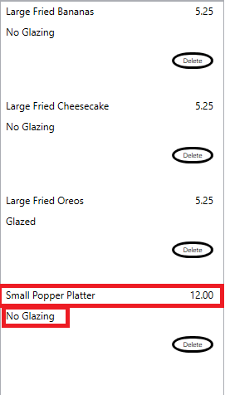

1. Check the Medium option under the ‘Customize Popper Platter’ section

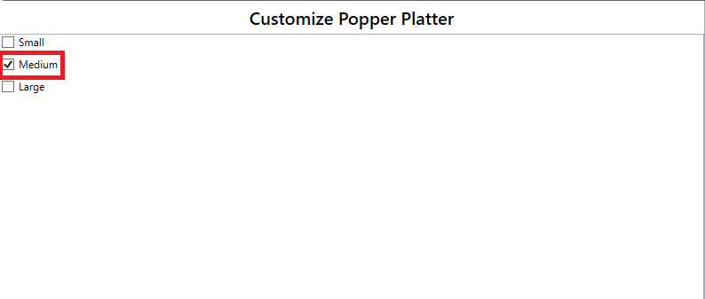

1. Verify that the name of the Menu Item is ‘Medium Popper Platter’ corresponding to the checked ‘Medium’ option. Also verify that the Medium Popper Platter has no glazing.

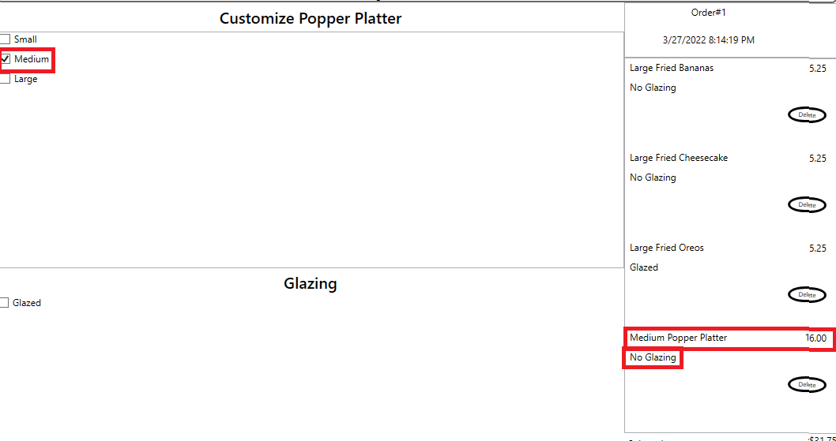

1. Verify that the price of the ‘Medium Popper Platter’ Menu Item is 16.00 and the SubTotal of the order is 3845, the sum of the Large Fried Bananas, Large Fried Cheesecake, Large Fried Oreos, and Medium Popper Platter.

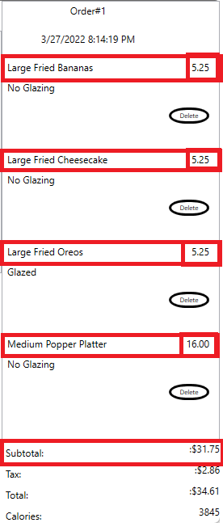

1. Verify that the Total is 34.61 and is the sum of the Subtotal and Tax. Also verify that the Calories is now 3845.

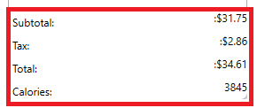

1. Check the Large option under the ‘Customize Popper Platter’ section



1. Verify that the name of the Menu Item is ‘Large Popper Platter’ corresponding to the checked ‘Large’ option

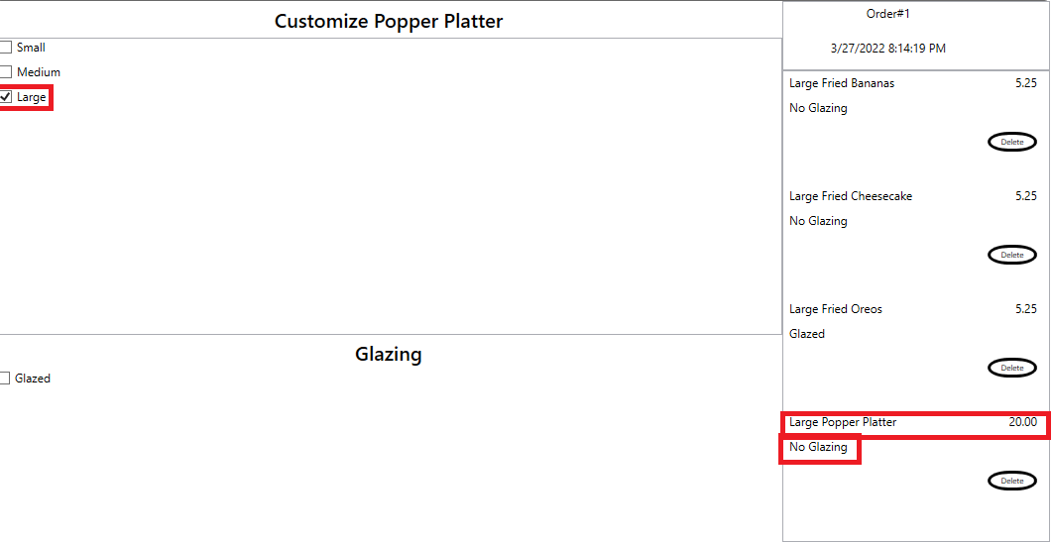

1. Verify that the price of the ‘Large Popper Platter’ Menu Item is 20.00 and the SubTotal of the order is 35.75, the sum of Large Fried Bananas, Large Fried Cheesecake, and Large Fried Oreos, and Large Popper Platter.

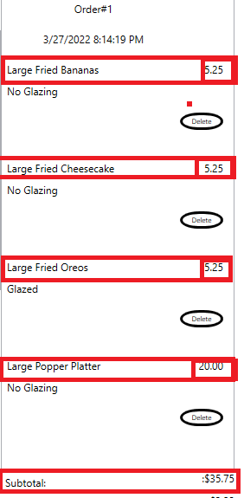

1. Verify that the Total is 38.9675 and is the sum of the Subtotal and Tax. Also verify that the Calories is now 4490.

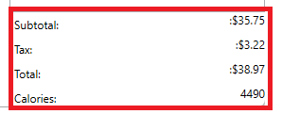

1. Click the ‘Select More Items’ button



1. Your window should now look like this.

1. Click the ‘Complete Order’ button

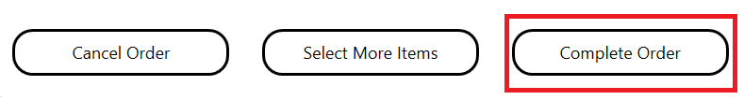

1. Your window should now look like this

1. Exit the Application

## Test #10 Adding FriedPiper

1. Fire Up the application. This Window should appear

1. Click the ‘Piper Platter’ Button under the ‘Platter’ section

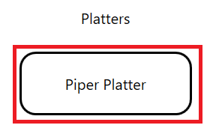

1. Your window should now look like this

1. Verify that the ‘Piper Platter’ menu item has a delete option

1. Verify that the ‘Piper Platter’ menu item contains two pie and two ice creams

1. Verify that the price of the Piper Platter is 12.00 and matches the SubTotal of the order.

1. Verify that the ‘Total’ is 13.08 and is the sum of the SubTotal and the Tax.

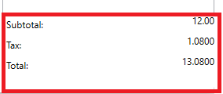

1. In the ‘Left Pie’ section of the customization screen click the ‘Peach’ option

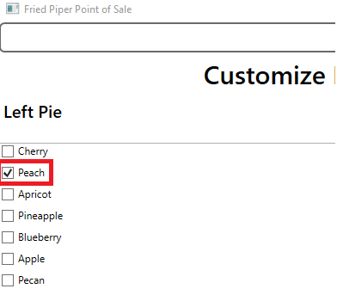

1. Verify that clicking the ‘Peach’ option changes the name of first pie under the piper platter.

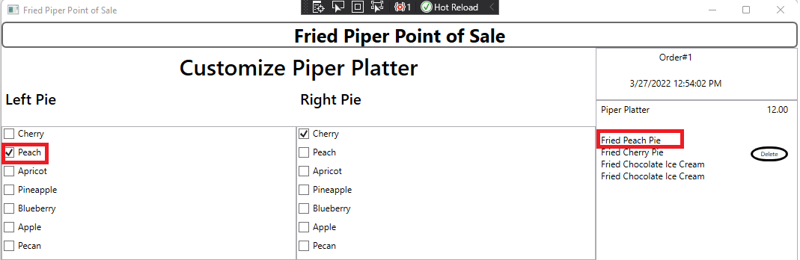

1. In the ‘Left Pie’ section of the customization screen click the ‘Apricot’ option

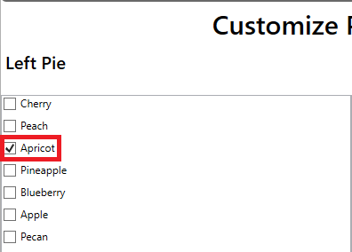

1. Verify that clicking the ‘Apricot’ option changes the name of first pie under the piper platter.

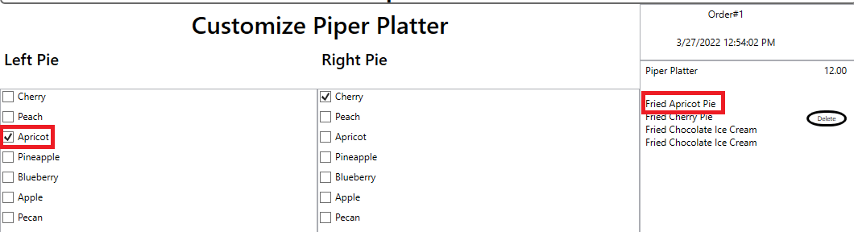

1. In the ‘Left Pie’ section of the customization screen click the ‘Pineapple’ option

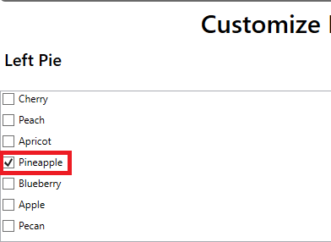

1. Verify that clicking the ‘Pineapple’ option changes the name of first pie under the piper platter.

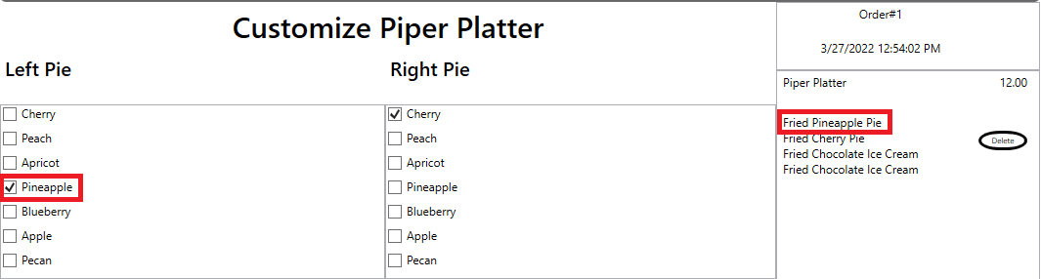

1. In the ‘Left Pie’ section of the customization screen click the ‘Blueberry’ option

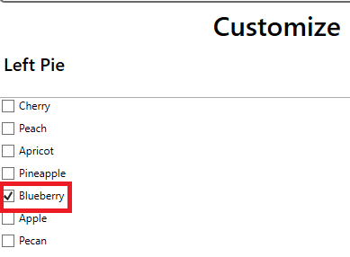

1. Verify that clicking the ‘Blueberry’ option changes the name of first pie under the piper platter.

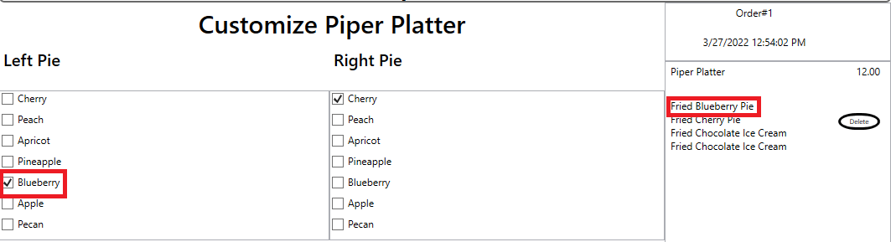

1. In the ‘Left Pie’ section of the customization screen click the ‘Apple’ option

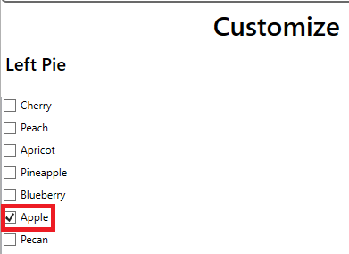

1. Verify that clicking the ‘Apple’ option changes the name of first pie under the piper platter.

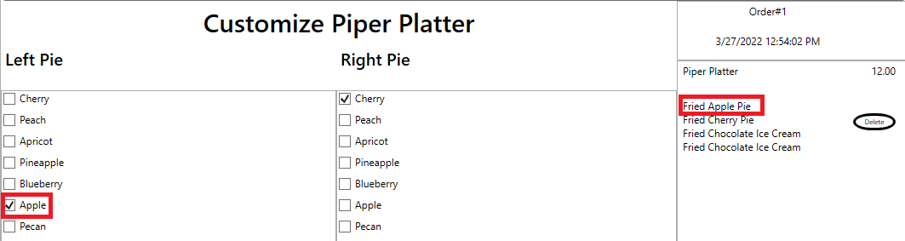

1. In the ‘Left Pie’ section of the customization screen click the ‘Pecan’ option

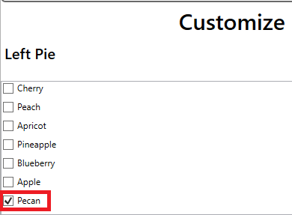

1. Verify that clicking the ‘Pecan’ option changes the name of first pie under the piper platter.

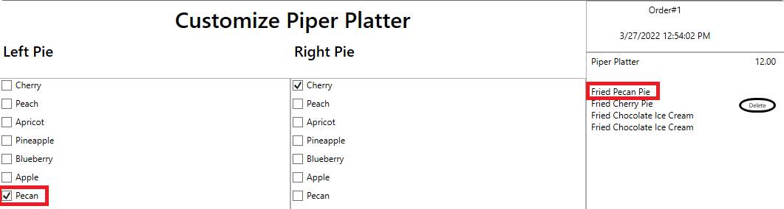

1. In the ‘Right Pie’ section of the customization screen click the ‘Peach’ option

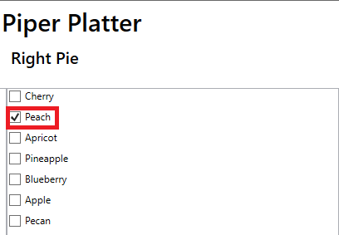

1. Verify that clicking the ‘Peach’ option changes the name of second pie under the piper platter. Verify that the name of the first pie remains ‘Fried Pecan Pie’

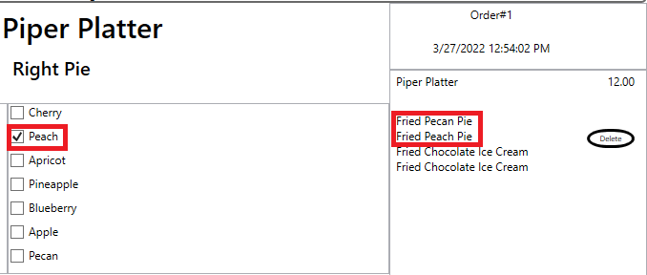

1. In the ‘Right Pie’ section of the customization screen click the ‘Apricot’ option

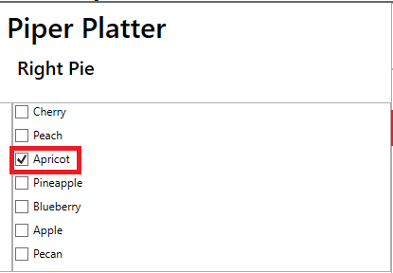

1. Verify that clicking the ‘Apricot’ option changes the name of second pie under the piper platter. Verify that the name of the first pie remains ‘Fried Pecan Pie’

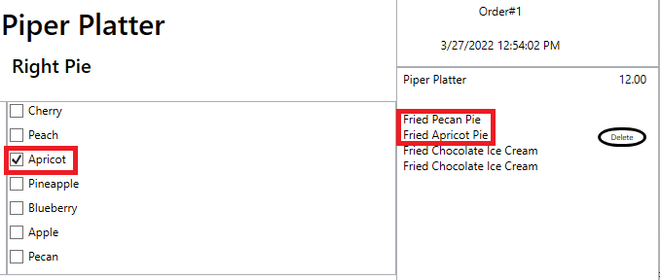

1. In the ‘Right Pie’ section of the customization screen click the ‘Pineapple’ option

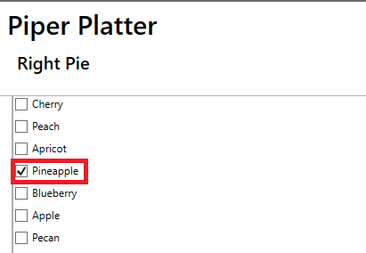

1. Verify that clicking the ‘Pineapple’ option changes the name of second pie under the piper platter. Verify that the name of the first pie remains ‘Fried Pecan Pie’

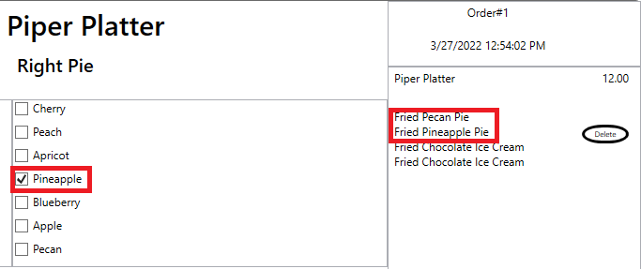

1. In the ‘Right Pie’ section of the customization screen click the ‘Blueberry’ option

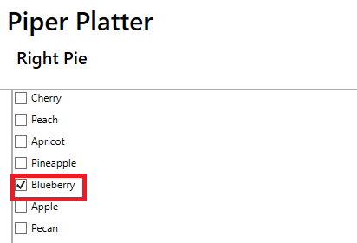

1. Verify that clicking the ‘Blueberry’ option changes the name of second pie under the piper platter. Verify that the name of the first pie remains ‘Fried Pecan Pie’

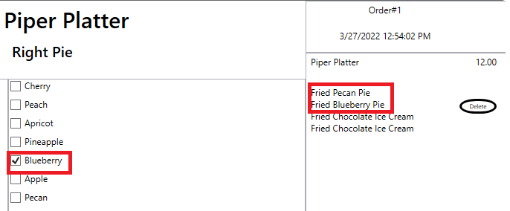

1. In the ‘Right Pie’ section of the customization screen click the ‘Apple’ option

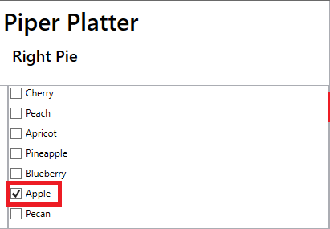

1. Verify that clicking the ‘Apple’ option changes the name of second pie under the piper platter. Verify that the name of the first pie remains ‘Fried Pecan Pie’

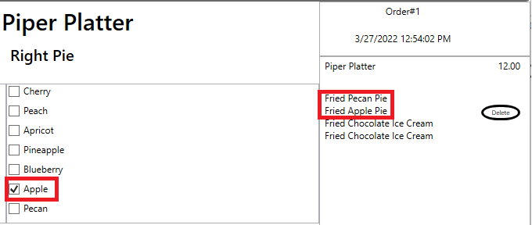

1. In the ‘Right Pie’ section of the customization screen click the ‘Pecan’ option

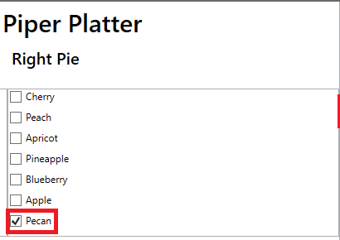

1. Verify that clicking the ‘Pecan’ option changes the name of second pie under the piper platter. Verify that the name of the first pie remains ‘Fried Pecan Pie’

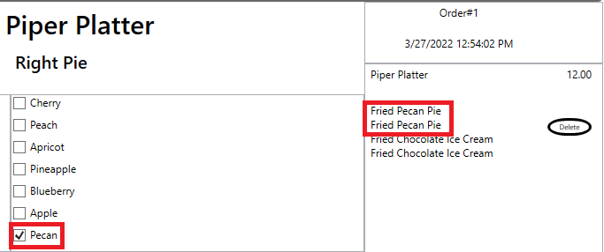

1. In the ‘Left Ice Cream’ section of the customization screen check ‘Vanilla’ option.

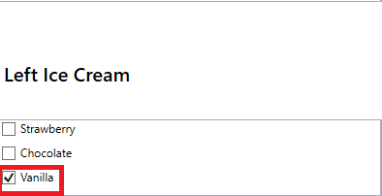

1. Verify that clicking the ‘Vanilla’ option changes the name of first ice cream under the piper platter. Verify that the name of the first and second pie remains ‘Fried Pecan Pie’

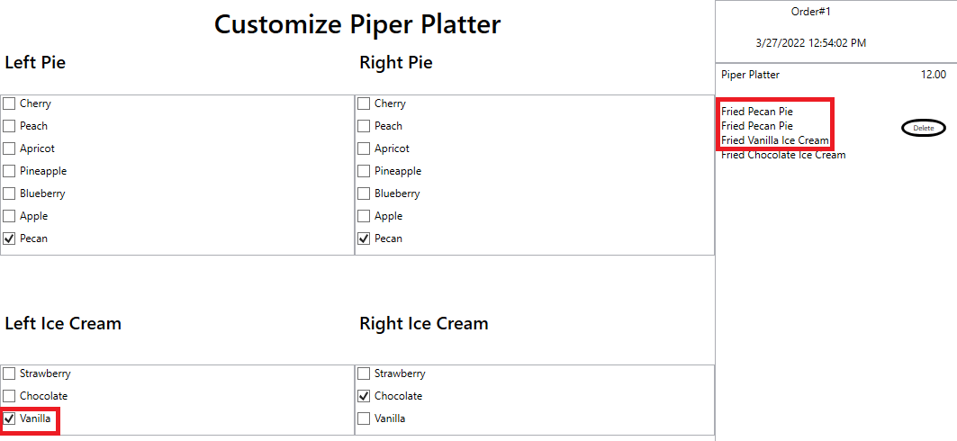

1. In the ‘Left Ice Cream’ section of the customization screen check ‘Strawberry’ option.

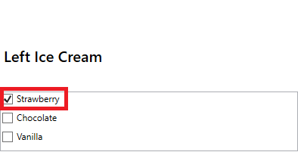

1. Verify that clicking the ‘Strawberry’ option changes the name of first ice cream under the piper platter. Verify that the name of the first and second pie remains ‘Fried Pecan Pie’

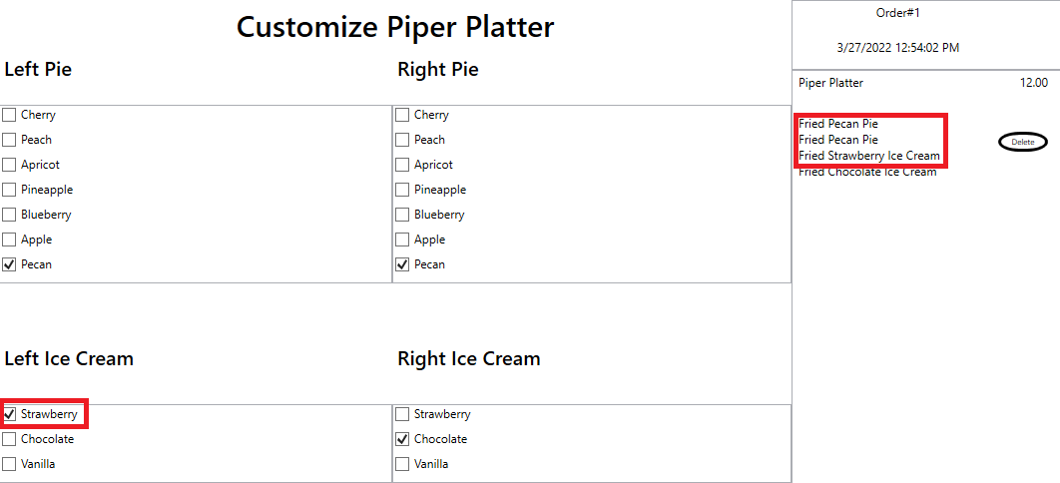

1. In the ‘Right Ice Cream’ section of the customization screen check ‘Vanilla’ option.

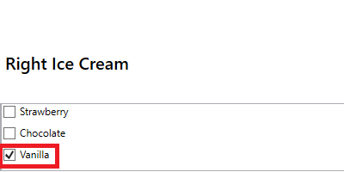

1. Verify that clicking the ‘Vanilla’ option changes the name of second ice cream under the piper platter. Verify that the name of the first and second pie remains ‘Fried Pecan Pie’, and the name of the first ice cream remains ‘Fried Strawberry Ice Cream’.

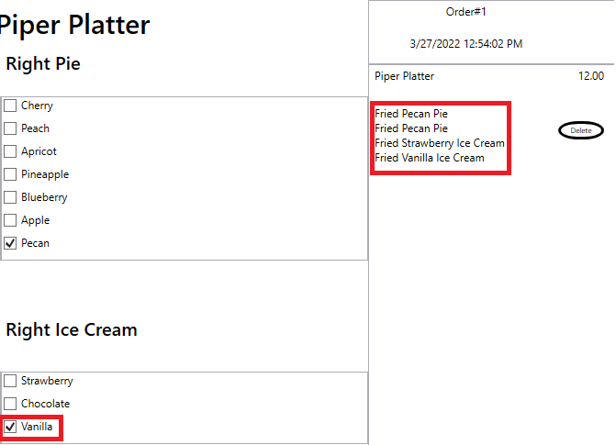

1. In the ‘Right Ice Cream’ section of the customization screen check ‘Strawberry’ option.

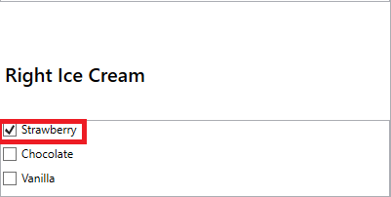

1. Verify that clicking the ‘Strawberry’ option changes the name of second ice cream under the piper platter. Verify that the name of the first and second pie remains ‘Fried Pecan Pie’ and the name of the first ice cream remains ‘Fried Strawberry Ice Cream’.

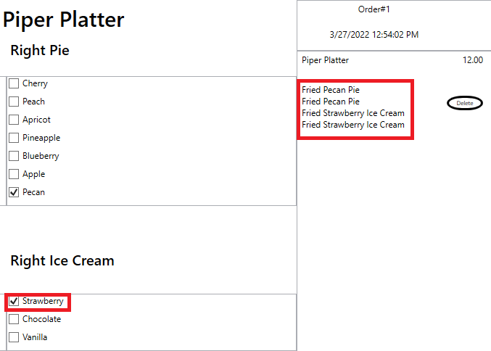

1. Click the ‘Select More Items’ button

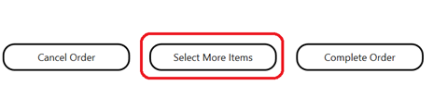

1. Your Window Should now look like this.

1. Click the ‘Cancel Order’ button

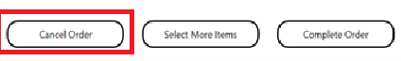

1. Your screen should now look this with your order number remaining the same.

1. Exit the Application.